OVERALL PROGRAMME EVALUATION REPORT
Social Entrepreneurship Development Program (SEDP)- Start Tanzania Module 3 (2nd February - 6th February 2026)
No. of Respondents: 18
No. of Participants: 267
Response Rate: 7%
--------------------------------------------------

Faculty Reports

Benard Chege - Business (social enterprise) planning
Evaluation Parameter | (%) Individual Score | (%) Programme Average
Punctuality (Commencement and Completion of Sessions) | 96 | 95
How well do you understand the core concepts presented? | 79 | 87
Rate your confidence in applying the new skills learnt | 84 | 88
Degree of Faculty preparedness for the sessions | 90 | 91
Content and methodology of the program | 88 | 91
Quality of class and group discussions | 83 | 89
The information presented in the course is relevant to my work (ministry) | 88 | 91
Average scores | 87 | 90

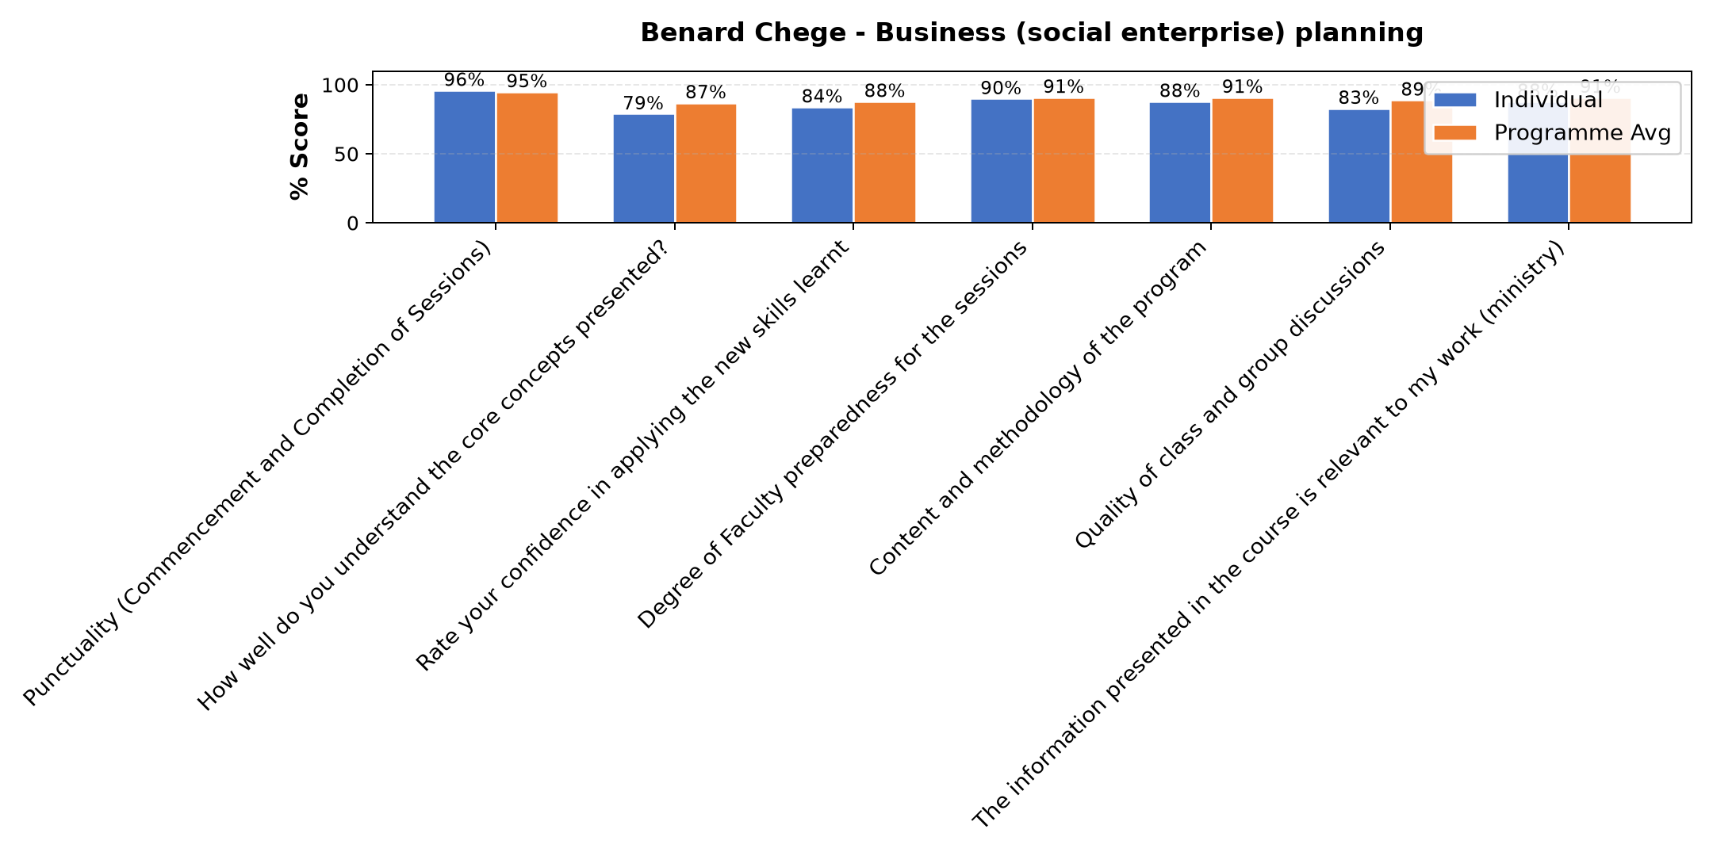

Comments & Feedback
No comments recorded.

Dr. Isaac Muiruri Gachanja - Funding sources
Evaluation Parameter | (%) Individual Score | (%) Programme Average
Punctuality (Commencement and Completion of Sessions) | 94 | 95
How well do you understand the core concepts presented? | 88 | 87
Rate your confidence in applying the new skills learnt | 89 | 88
Degree of Faculty preparedness for the sessions | 91 | 91
Content and methodology of the program | 92 | 91
Quality of class and group discussions | 90 | 89
The information presented in the course is relevant to my work (ministry) | 92 | 91
Average scores | 91 | 90

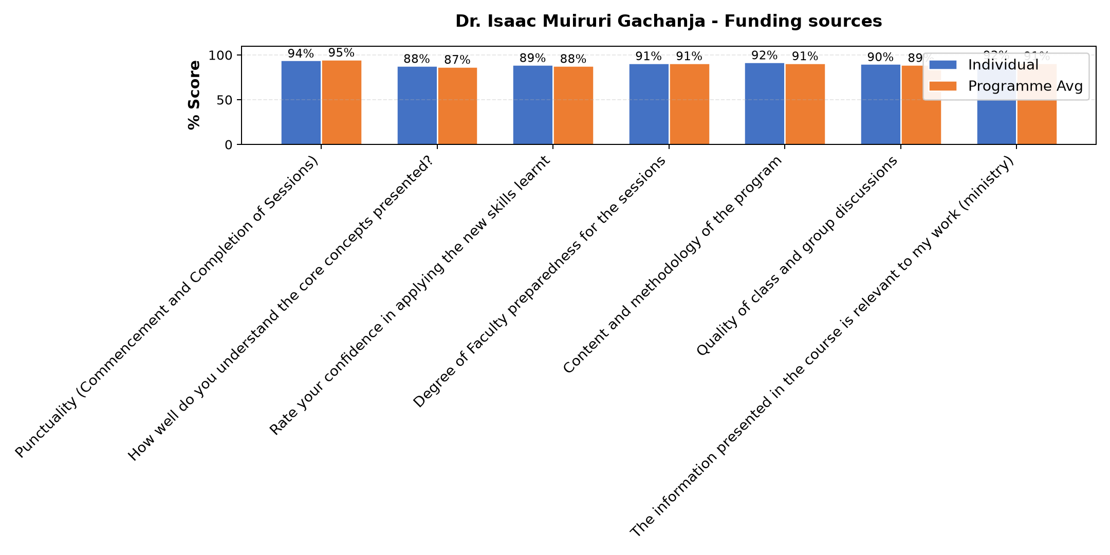

Comments & Feedback
- • Good
- • Nitajitahidi kutumia elimu niliyoipata kuinufaisha jamii pia
- • If I stay for a long time without implementing it, I will not achieve it.Goals
- • Asante kwa mafundisho mazuri nitajitahidi kuyafanyia kazi
- • Confidence
- • If I stay without implementing for a long time, I will fail to achieve my goals.
- • Smart
- • To find a capital in different areas
- • Nashukuru Mwalimu Isaac kwa kutufundisha vizuri

Janet Wanjiku - Monitoring and social impact measures
Evaluation Parameter | (%) Individual Score | (%) Programme Average
Punctuality (Commencement and Completion of Sessions) | 95 | 95
How well do you understand the core concepts presented? | 88 | 87
Rate your confidence in applying the new skills learnt | 87 | 88
Degree of Faculty preparedness for the sessions | 92 | 91
Content and methodology of the program | 93 | 91
Quality of class and group discussions | 92 | 89
The information presented in the course is relevant to my work (ministry) | 91 | 91
Average scores | 91 | 90

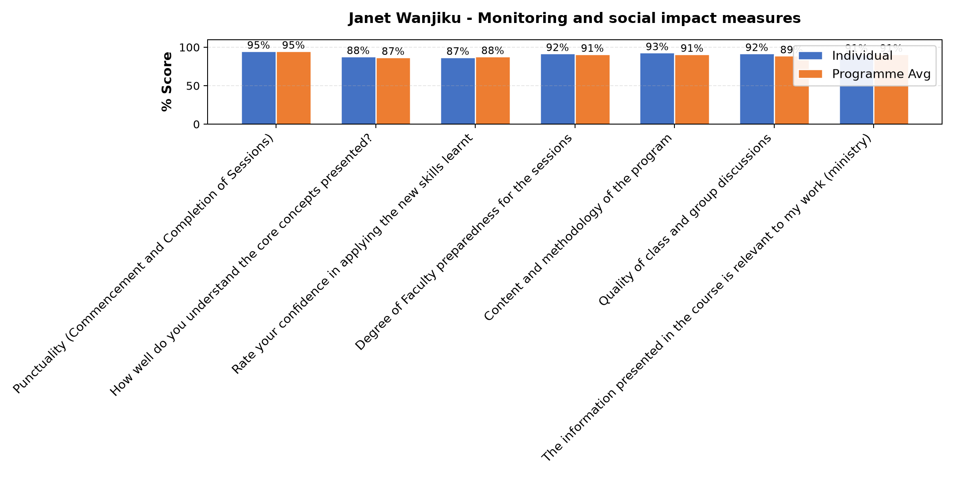

Comments & Feedback
- • Finance
- • Mambo yote yalienda sawa Nitajitahidi kutoa elimu kwa jamii iweze kupata maendeleo pia na mradi uweze kukua.
- • Net work and other on line things
- • She is a good Teacher
- • Lack of regular exercise
- • Good
- • The limited cooperation of my fellow community members
- • It was smart and well prepared

Dr. Diana Kageha Ominde - Operational efficiency
Evaluation Parameter | (%) Individual Score | (%) Programme Average
Punctuality (Commencement and Completion of Sessions) | 100 | 95
How well do you understand the core concepts presented? | 92 | 87
Rate your confidence in applying the new skills learnt | 96 | 88
Degree of Faculty preparedness for the sessions | 96 | 91
Content and methodology of the program | 96 | 91
Quality of class and group discussions | 93 | 89
The information presented in the course is relevant to my work (ministry) | 96 | 91
Average scores | 96 | 90

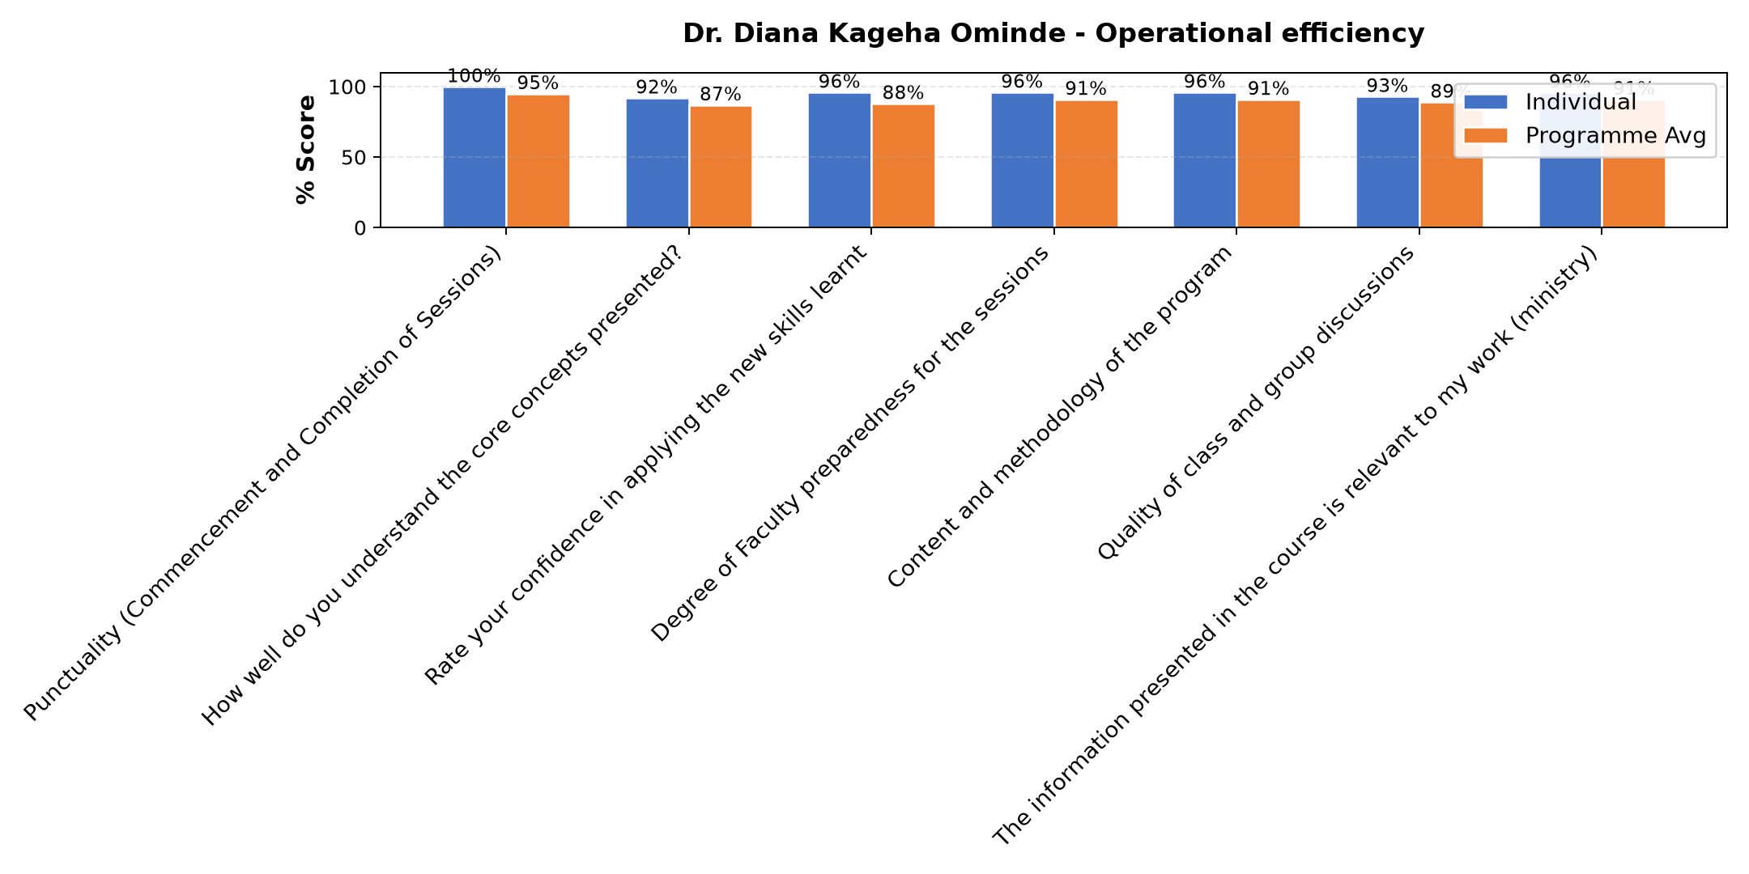

Comments & Feedback
- • If I don't collaborate with the community and don't keep the project information well-organized
- • Nothing
- • Naomba Mungu mafunzo haya niweze kuyafa nyia kazi
- • Smater
- • Kilichobaki ni utekelezaji TU Asante kwa mafundisho mazuri
- • Very good
- • Nashukuru kwa elimu niliyopata ukitoka kwa Mwalimu nitaifanyia kazi
- • Good presentation
- • She did alot

Susan Njoroge - Sustainability in social enterprise
Evaluation Parameter | (%) Individual Score | (%) Programme Average
Punctuality (Commencement and Completion of Sessions) | 88 | 95
How well do you understand the core concepts presented? | 87 | 87
Rate your confidence in applying the new skills learnt | 82 | 88
Degree of Faculty preparedness for the sessions | 84 | 91
Content and methodology of the program | 86 | 91
Quality of class and group discussions | 89 | 89
The information presented in the course is relevant to my work (ministry) | 89 | 91
Average scores | 86 | 90

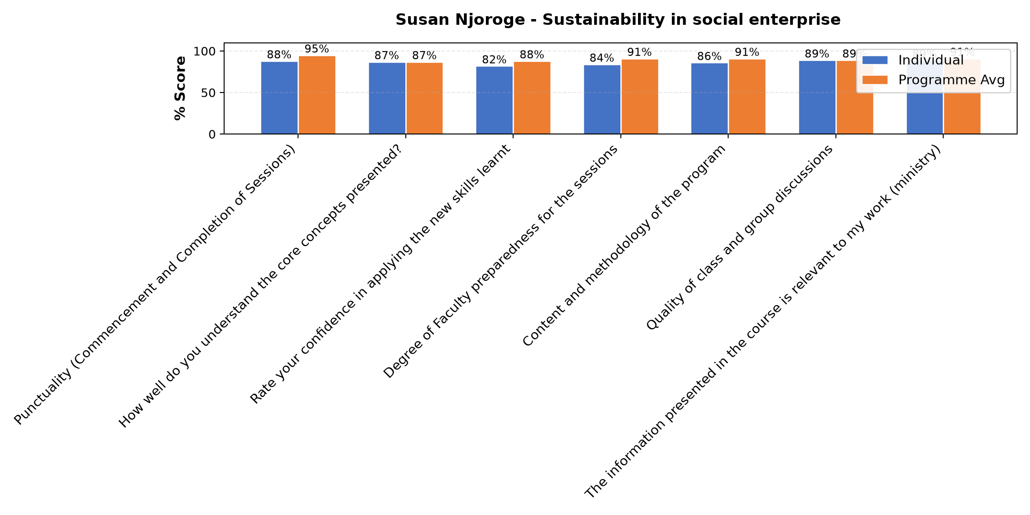

Comments & Feedback
- • Nitajitahidi kutumia elimu niliyojifunza kuinua uchumi kwa shirika na jamii
- • Language
- • Somo lilikuwa zuri nitajitahidi biashara yetu isife
- • Fedha
- • Net work in my social enterprise
- • Climatic change
- • No enough income
- • Lack of proper planning and management makes our activities unsustainable.
- • Nitajitahidi kutumia elimu niliyopata kuendeleza mradi usife

Department Reports

Are there any other comments and/or suggestions that you may want to add?

Comments & Feedback
- • I think it's better the kitchen department to adjust their time table so the we can also follow it.
- • Zaidi sana namshukuru Mungu nimelala vizuri mbu hakuna.
- • I am educated more through this treining
- • It is self-sufficient.
- • There was no hot water in rooms.
- • I was comfortable with the Programme.
- • Next time change the place.
- • Food was not attractive

Program Manager ( Venance Mwakangale )
Evaluation Parameter | (%) Score
Punctuality in sending materials and programme information | 99
Communication skills(verbal and written) | 95
Response to programme enquiries via email, whatsapp and calls | 95
Accessibility and willingness to support when needed | 96
Quality of service / professionalism | 92
Average score | 95

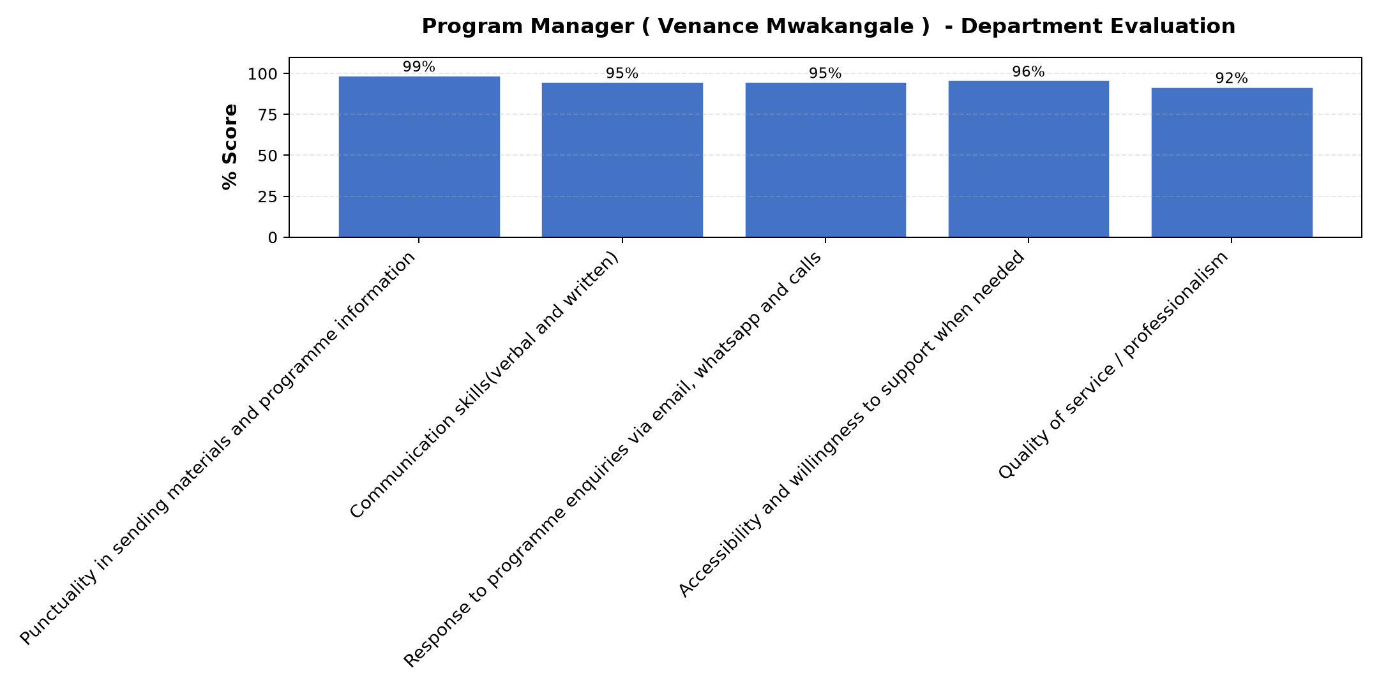

Comments & Feedback
- • Asante
- • Thank you so much
- • Mungu akubariki kwa majitoleo Yako kaka Venance hakuna kitu tumekosa.
- • He is very simple when you need any need from him
- • He sacrifice himself to everyone
- • He works well and consistently.
- • He is active, humble person with respect to all, and cooperative person.
- • We needed to develop more in finding sources and improving our language too
- • He is very commited.
- • V.good

Accommodation Venue
Evaluation Parameter | (%) Score
Comfort and cleanliness of the accomodation | 83
Quality of meals and dining services provided | 75
Overall satisfaction with the accomodation experience | 75
Average score | 78

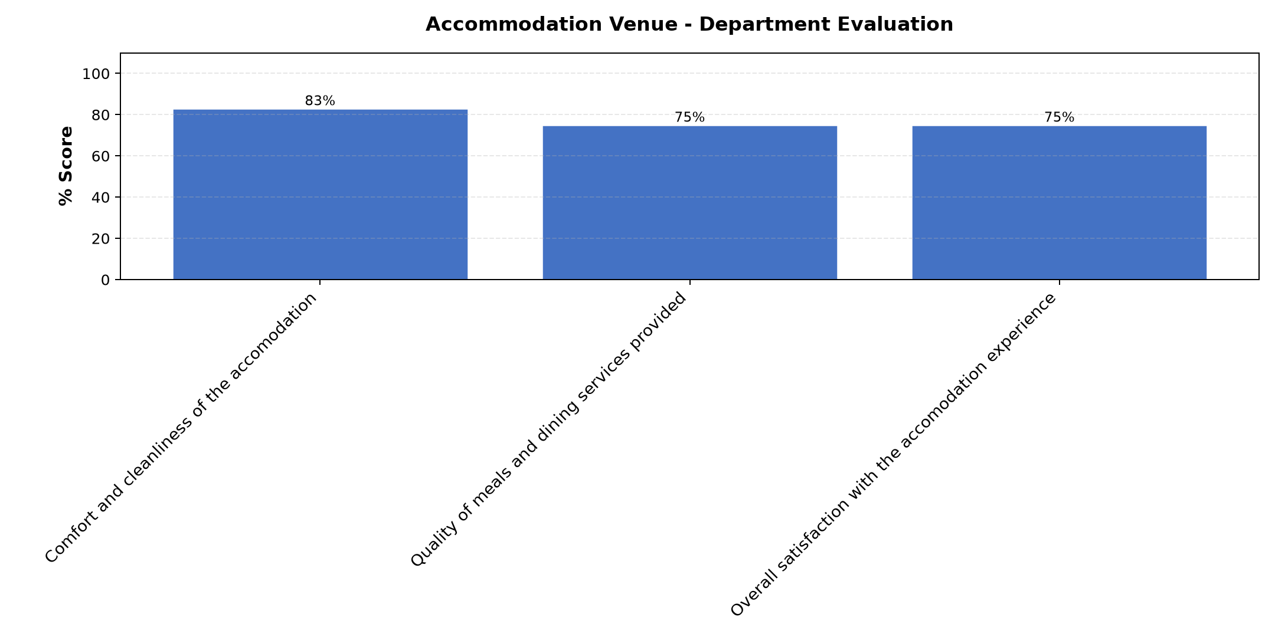

Comments & Feedback
- • Good
- • Time management for meals was poor, this was affecting us in some other areas even in doing personal activities or reflecting on what we have studied
- • Asante
- • Improvement in mattress
- • No 69 maji bafuni hayaendi vizuri yanaja ukioga.
- • They do according theire level
- • I have appreciated everything which you have put on our disposition
- • He has taught well.
- • Same how

Day 1 Comments

Comments & Feedback
- • Asante kwa kutufundisha vizuri Mungu akubariki
- • can teach Others understand.
- • Thank you so much
- • Nashukuru kwa mafunzo na kujua maana ya mpango kazi
- • The lesson was prepared good and the teacher is very simple acoding to the Paris plants
- • Good
- • Asante Mwalimu kajitahidi sana kufafanua kwa Kilammoja na kumuuliza ameelewa alichofundishwa.
- • Language barrier
- • Namshukuru Mwalimu
- • It mighty be needed but language
- • The teacher was active and well prepared

Day 2 Comments

Comments & Feedback
- • Very good
- • Mungu akubariki Mwalimu kwa mafundishoyako mazuri
- • I will practice what I have been taught.
- • The lesson was enjoyable
- • Asante kwa kutuvumilia Mwalimu
- • I will improve after gain knowledge of this course
- • I will implement and follow what I was taught.
- • Understand
- • The preparation of the lesson so good and the teacher so simple
- • Asante kwa kutuvumilia pale tuliposhidwa kujibu maswali.

Day 3 Comments

Comments & Feedback
- • The lesson is good, it gives me the courage to continue with social entrepreneurship and Touching the larger community
- • The lesson was enjoyable and active
- • Asante kwa kutuvumilia Mungu akubariki sana Dr Diana
- • Understandble
- • Ni somo nzuri sana nitajitahi kutumia elimu niyofundishwa kwa ajili ya shirika na jamii kwa ujumla
- • Very good
- • Asante Mungu akubariki sana
- • Well done

Day 4 Comments

Comments & Feedback
- • Thank you
- • Asante Dr janeth kwa ufafanuzikuhusu miradi yetu kati ya jamii inayotuzunguka
- • It was so nice class
- • The lesson was good and enjoyable
- • The lesson is good and beneficial for our organization.
- • Good
- • This means if the sister will not work hand to hand with
- • I need more practical information about the program

Guest-Speaker Session
Evaluation Parameter | (%) Score
Speaker's Quality of discussions | 83
Speaker's degree of preparation for the session | 84
Information presented in the course was relevant to my work | 84
Presentation was well structured | 81
Delivery methodology was appropriate | 80
Average score | 82

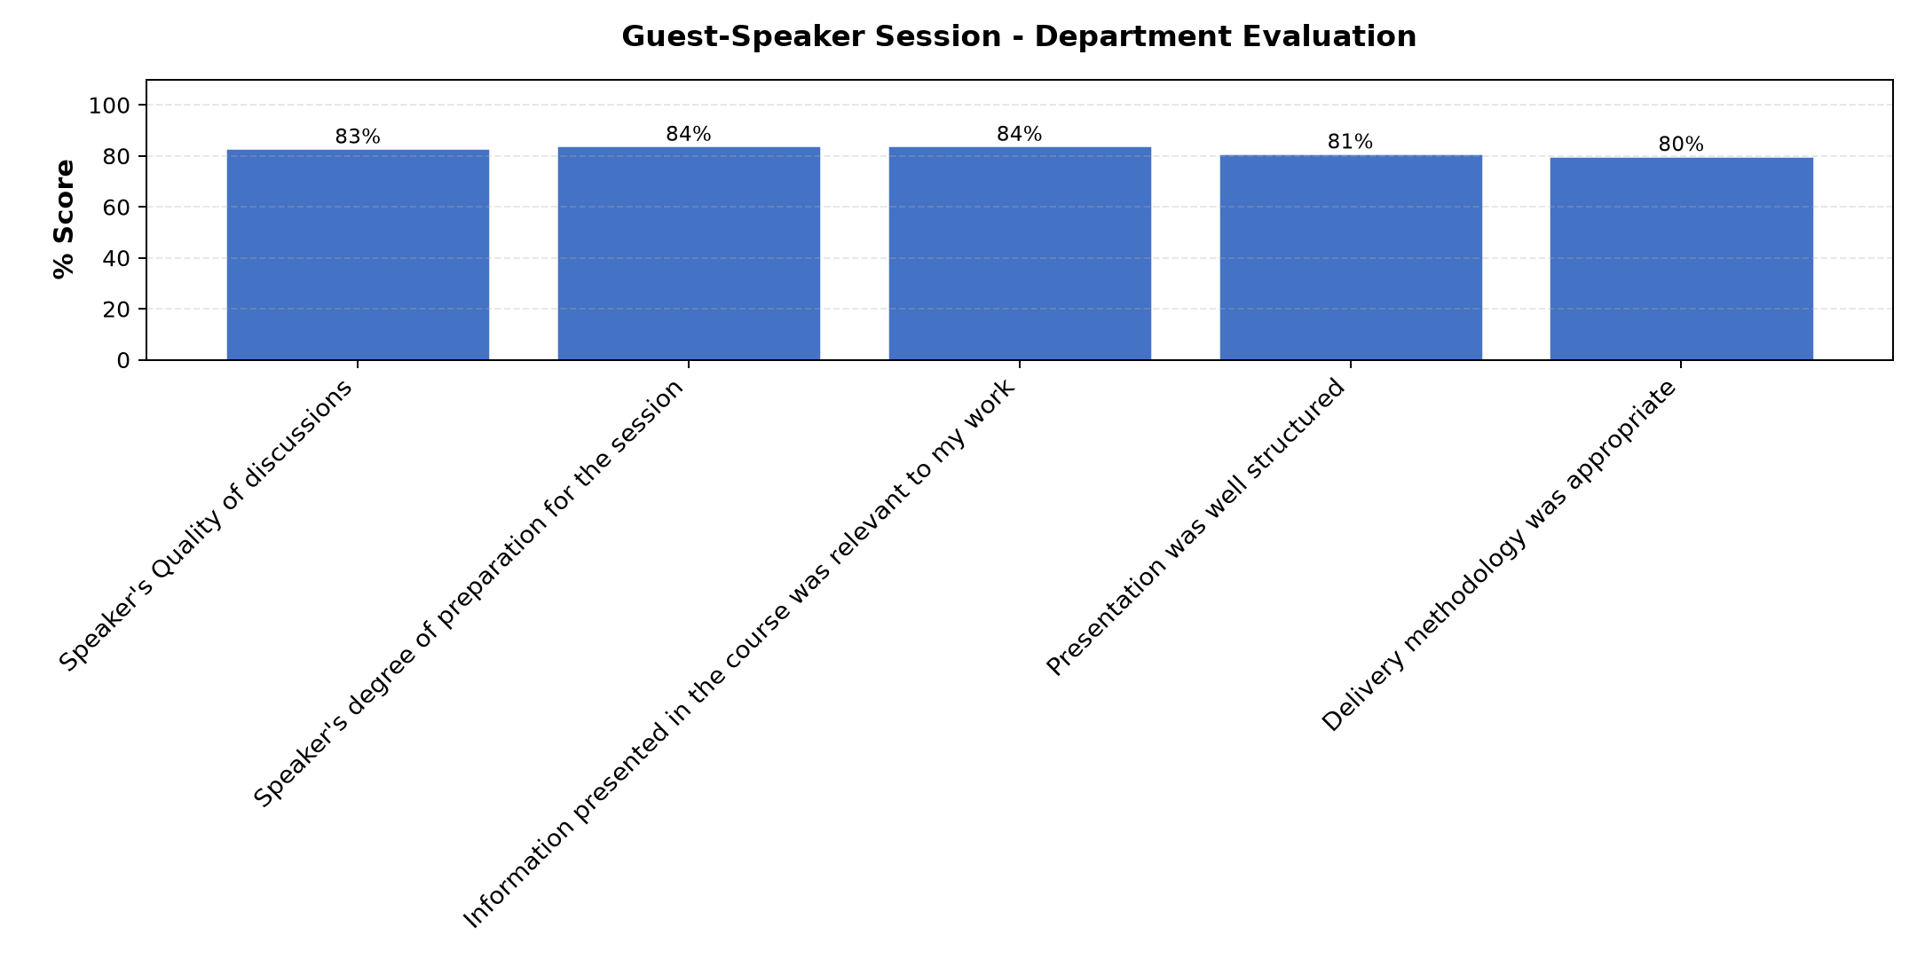

Comments & Feedback
- • Asanten
- • Somehow it will help me in my social enterprise
- • Nashukuru ufafanus niliyopata kidogo kuhusu TRA
- • Berry nice
- • He has given me the openness about TRA taxes
- • Nil
- • He is understood.
- • Good
- • The time was short
- • Well intended to meet our target
- • The teacher was to high that the learners. So the lesson was was not attractive.

Overall Evaluation
Evaluation Parameter | (%) Score
Overall program evaluation | 93
Average score | 93

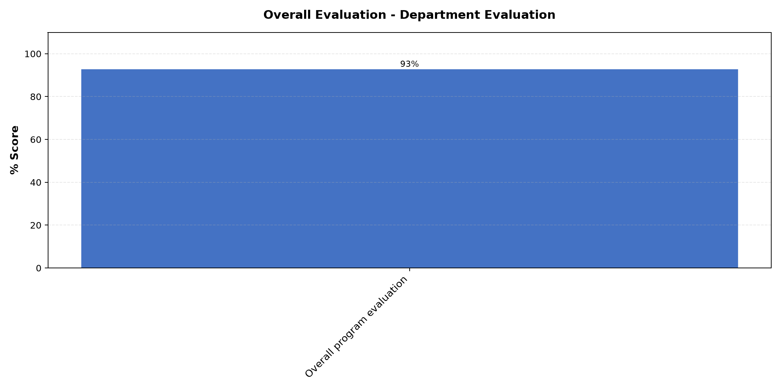

Comments & Feedback
No comments recorded.

Social Enterprise Visit
Evaluation Parameter | (%) Score
Quality of the pre-visit planning & information shared.1 | 94
Quality of the plant visit | 87
Quality of content discussed.1 | 92
Overall company visit evaluation.1 | 93
Average score | 92

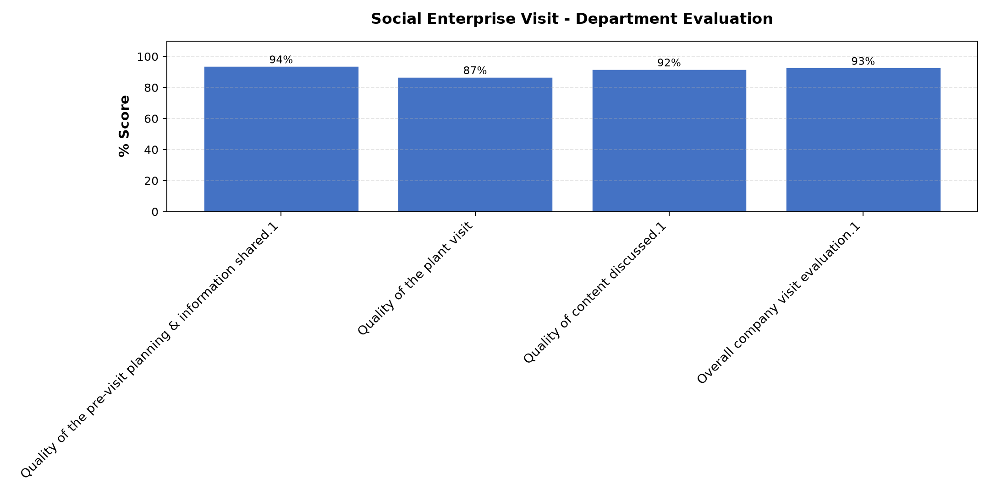

Comments & Feedback
- • Somo zuri somo la Leo zuri sana
- • Good presentation
- • Nashukuru sana kwa kunielimisha Mungu akubariki
- • Mungu mwema Asante sana
- • Iam really enjoyed God Bless your mission
- • Thank you very much
- • The visit was enjoyable and beneficial for our project.
- • Management is good.
- • Asante kwa mafundisho mazuri

Venue Evaluation
Evaluation Parameter | (%) Score
Suitability of training venue (space, layout, facilties) | 81
Comfort and cleanliness of the training environment | 79
Availability and quality of training amenities(projector, sound, Wi-Fi) | 83
Average score | 81

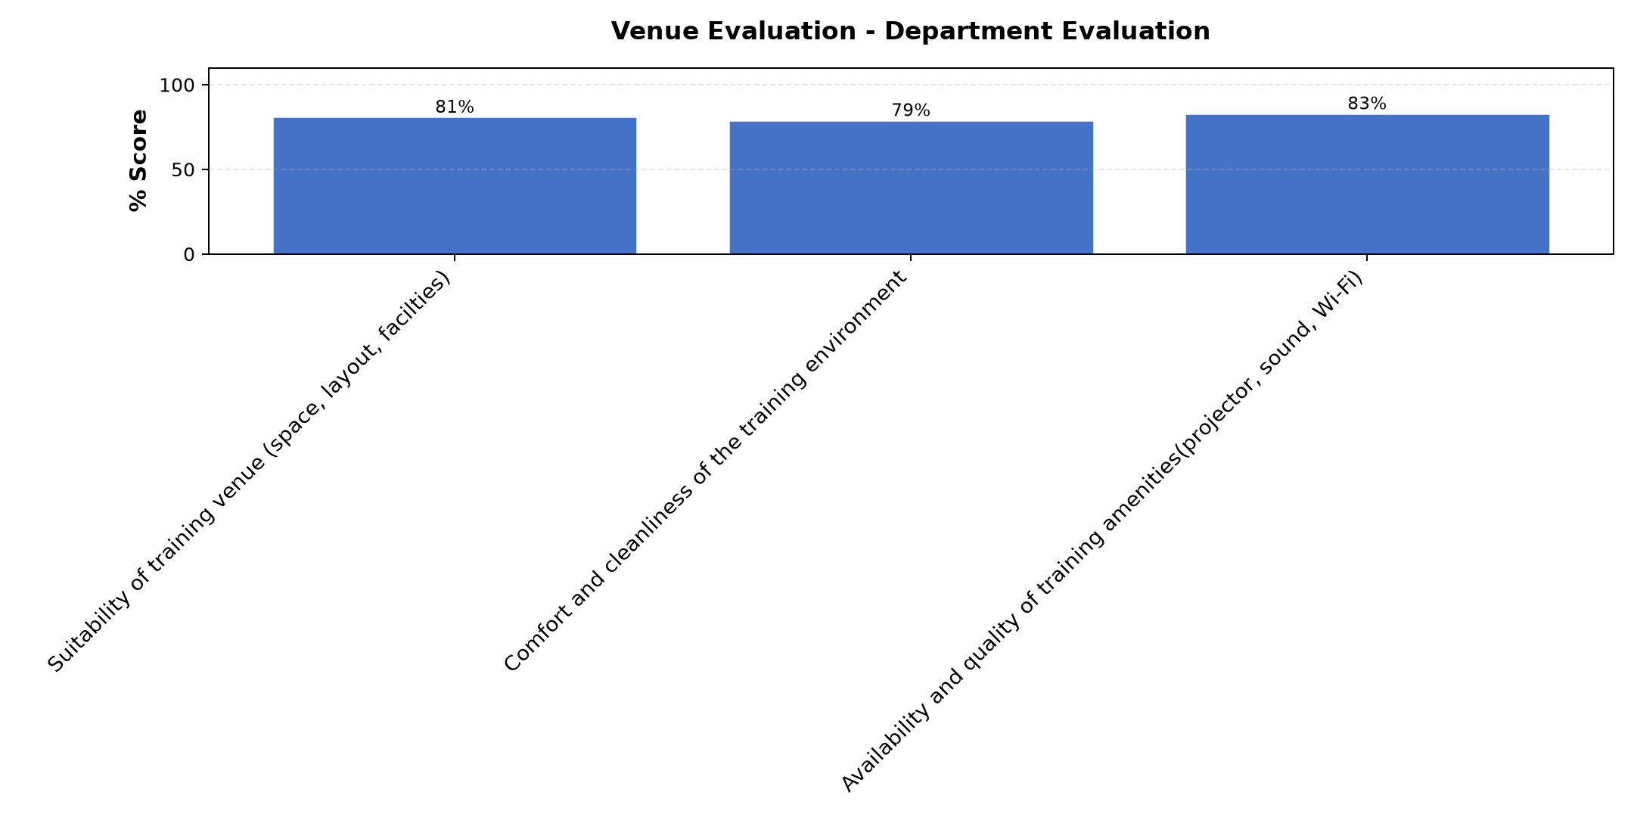

Comments & Feedback
- • Thank
- • Thank you
- • Mambo mengine yote yalikuwa mazuri isipokuwa WiFi ilikuwa chini.
- • Very nice
- • Improve them
- • TEC was more better than Mbagala and very far
- • Good
- • The WI-FI was low which was affecting us to do some of the class work.

What attracted you to the programme??

Comments & Feedback
- • The way to improve my social enterprise and how I can sustain them and also how I can get funding
- • Teacher use simple language in teaching that make me to understand well.
- • Walimu hawana Ubaguzi hata kama mtu hukutoa jibu zuri yeye anasaidia mpaka uelewe vizuri nasema Mungu awabariki sana by
- • The valley of death
- • Methods
- • Very good, continue to share with others
- • Interaction was very interesting to me
- • Language in understanding
- • Mazungumzo kati yetu na Kaka Venance na Sr. Lucy at our place Morogoro.
- • The visit of the company was fantastic and wonderful.

What topic would you recommend being expanded/improved in this programme’s units?

Comments & Feedback
- • Operational Efficiency
- • About taxation
- • Namna ya kuendeleza biashara zetu na kuweza kuanzisha biashara nyingine na namna yakutafuta pesa.za kuendelezea mradi
- • Monitoring and social impact measures
- • Funding social venture
- • How will our businesses grow sustainably?
- • Monitoring and social impact
- • Record, monitoring planing efficiency
- • Business plan
- • How to impact stakeholder

Which areas in this programme did you find most important to your social enterprise?

Comments & Feedback
- • LinkedIn
- • Operational efficiency
- • Ni sehemu ya kukata Leseni ya biashara maana miradi yetu baadaye inaweza kukua na kuwa biashara kubwa Mungu akitunalia.
- • Social planing enterprise
- • Mostly sustainability in social Enterprise
- • All areas
- • We will educate the wider community accurately
- • Vey
- • Each area touched in this programm was relevant to my social enterprise
- • Planing,fundraising, operational efficiency ES sustainability Monitoring and evaluation
- • Both topics are important to my project.
- • A) Fundraising
B) Planning and budgeting
C) Sustainability in social enterprise
D) Story telling and operational efficiency

Which teaching methods applied in the course did you enjoy/learn from the most?

Comments & Feedback
- • Group discussion and case study
- • Discussion, question and answer
- • Njia ya kuulizwa maswali na majadiliano/ Discussion.
- • Dialogue and group discussion
- • Working and discussion in group
- • All
- • They have taught well with love and have been understood.
- • The method of discussion helped me to learn more from others and the use of the power point (Using the projector)
- • Class with activities
- • Yes
- • Teamwork used by all teachers
- • Group work in different ways to make sure that all have participate

